TCP 1 Write up

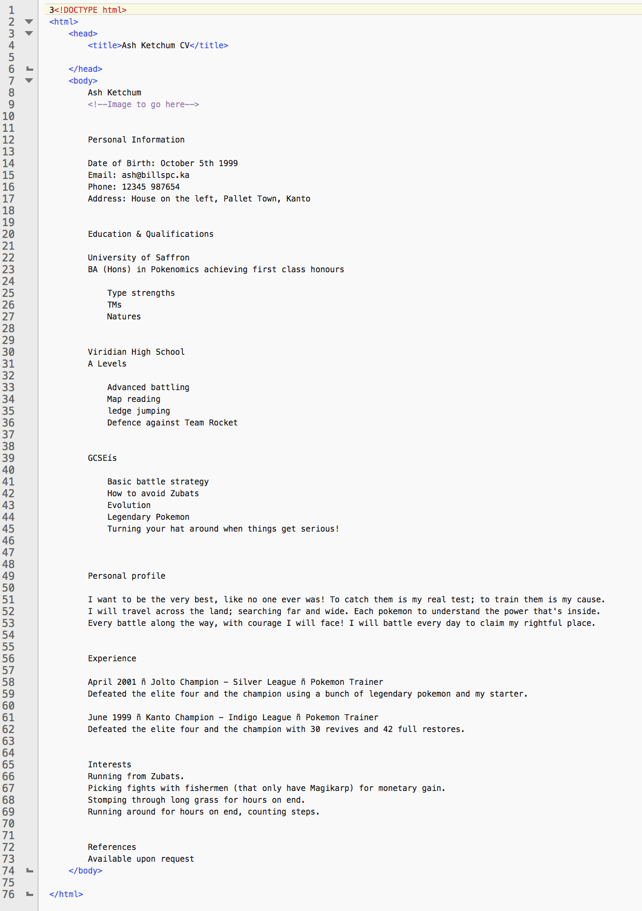

Task 1) Task one involved downloading a CV that was un-formatted, we had to then use our edit tool to open it and look at its structure. Following that we needed to open the CV in a we browser to see what un tagged text would look like.

Task 2) We found that opening the untagged document made just a big stack of text with no breaks or paragraphs ( a mess for short). This is due to the lack of structure tags, without these the browser just sees a large lump of text.

Task 3) With an example CV in the format required we set about editing the formatting, we started with the name, using a <h1> tag to specify it as a header, having done this we then checked it had worked by saving then refreshing the webpage.

Task 4) over the course of the hour we used the example html tags and some others we found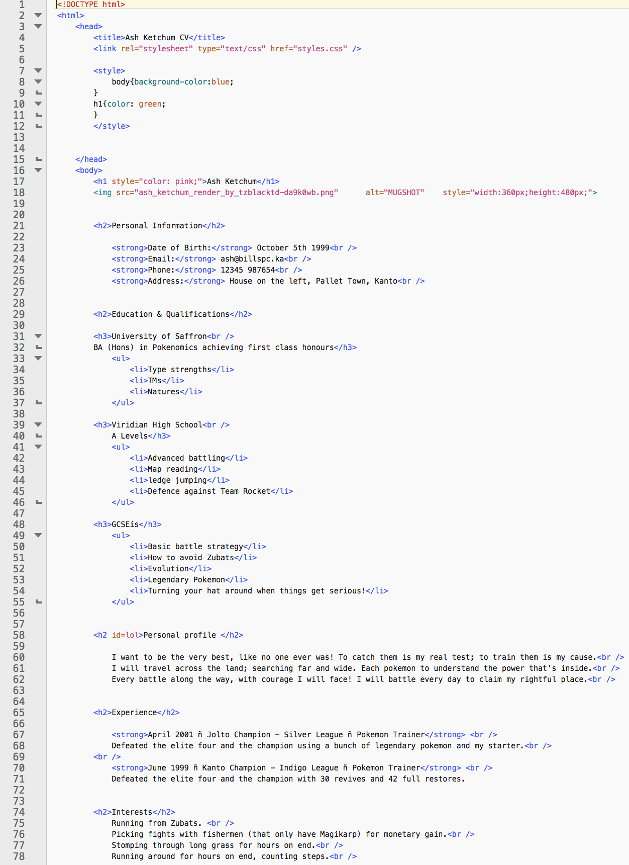 ourselves to edit the CV to resemble the example more and more closely. This involved using breaks and paragraphs, as well as other tags.

Task 5) We finally found an image to add to the document using the href tag and sizing it appropriately.

Task 6) Creating a new html document involved using the opening and closing tags;

<!DOCTYPE html>

<html>

<head>

</head>

<body>

</body>

</html>

these show different areas of the document as well as what language the document is in and what the browser is shown.

Task 7) I had to research how to make html tables, then create a table of 3 rows and 2 columns, I used the <tr> and <th> tags inside a <table> tag.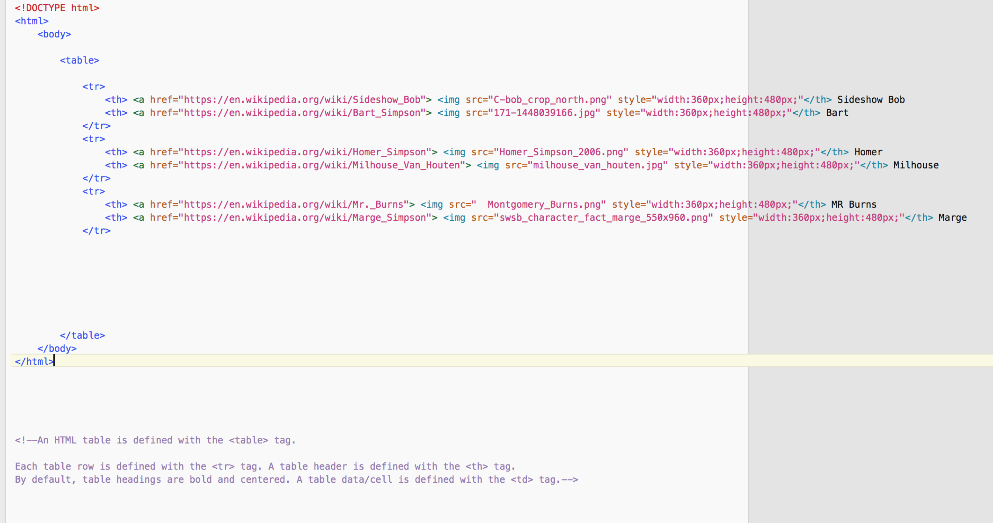

Task 8) We then added images of a simpsons character to each cell and their name below the image. This was done with the <img> tag.

Task 9) In task 9 we had to add a link so that when we clicked the cell it would open the related characters wiki page. This was done using the <a href > tag.

